Graduation Project Proposal

Project Title | Hydrodynamic–Structural Design and Optimization of Myring-Shaped Autonomous Underwater Vehicles
Classification | Research project
Supervisor | Assoc. Prof. Dr. Bertan Beylergil
Abstract | This project aims to investigate the coupled hydrodynamic and structural design of a Myring-shaped autonomous underwater vehicle (AUV) and to determine geometric configurations that provide improved overall performance. The study will focus on the main parameters defining the external Myring profile, including the nose, cylindrical body, and tail sections, and will examine how changes in these parameters affect hydrodynamic resistance, structural stiffness, natural frequencies, and mode shapes.  The structural response of the AUV hull will be evaluated using a semi-analytical formulation based on first-order shear deformation theory (FSDT) and the Ritz method. This approach will allow the influence of shell geometry and thickness on the dynamic behavior of the vehicle to be studied with substantially lower computational cost than a fully numerical model. The semi-analytical results will be verified using finite element analyses to assess the accuracy of the proposed formulation over the selected design range.  Hydrodynamic performance will be evaluated under representative operating conditions, with particular attention to the selected cruising speed of 2.0 m/s. The effects of the main geometric variables on drag and overall hydrodynamic efficiency will be examined together with their influence on structural and vibration characteristics. Rather than treating these aspects independently, the project will combine the hydrodynamic and structural responses within a common design procedure.  The resulting database will be used to identify the most influential design parameters and to establish the trade-offs between low hydrodynamic resistance, structural rigidity, mass, and vibration behavior. An optimization procedure will then be carried out to determine AUV configurations that satisfy the required structural and dynamic constraints while maintaining favorable hydrodynamic performance. The study is expected to provide a computationally efficient design approach for small Myring-shaped AUVs and to clarify how geometric modifications influence both the flow-related and structural behavior of the vehicle.

The graduation project is the subject of the MEC 401 Mechanical Engineering Design and MEC 402 Graduation Project courses offered in the 7th and 8th semesters, respectively.

Course Name | MCE Graduation Project I
Prerequisites
Corequisites
Requirements | Basic knowledge of a MATLAB, Intermediate knowledge of solid modelling
Workflow | - Literature survey  - FEM analysis  - Midterm presentation  - Mathematical modeling  - Project report  - Final presentation

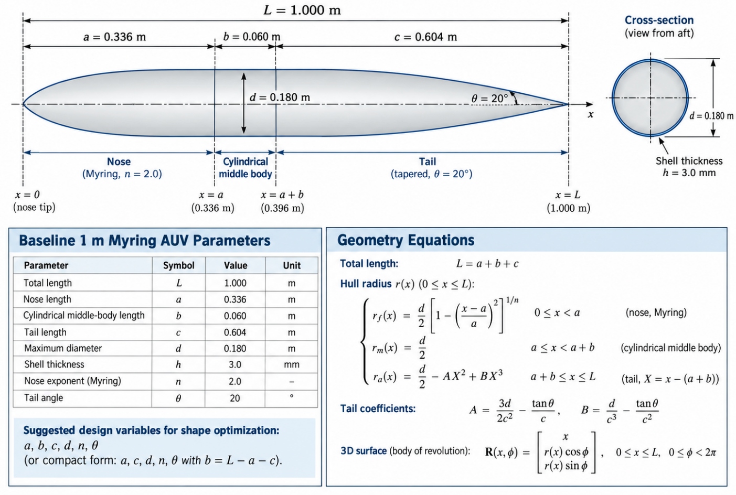
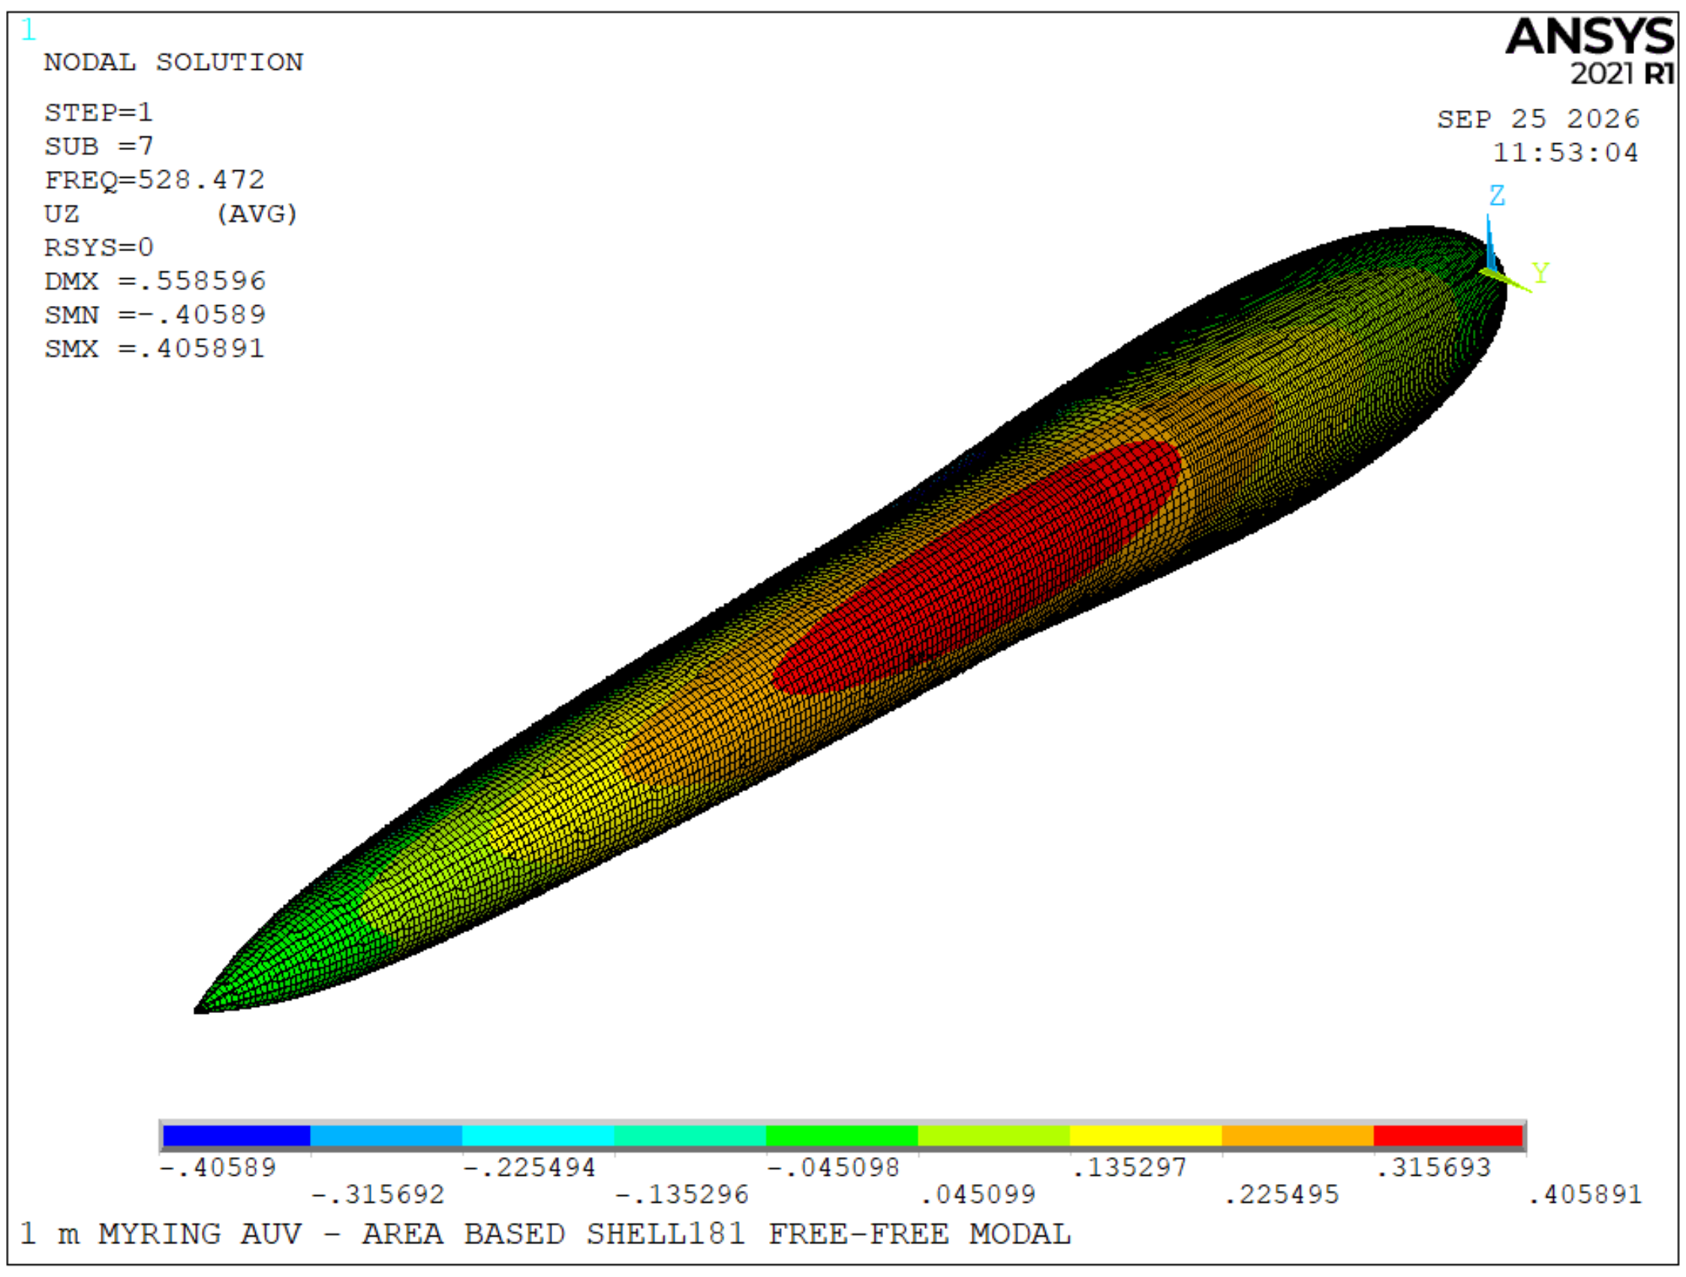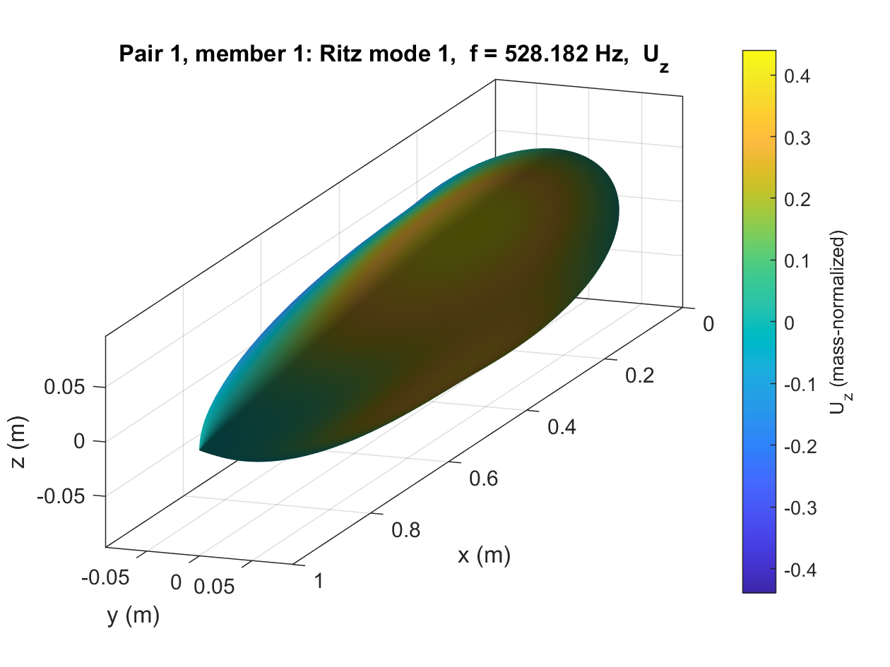

Term | 2026-2027 Fall Semester
Date
Project Title | Hydrodynamic–Structural Design and Optimization of Myring-Shaped Autonomous Underwater Vehicles
Supervisor Name and Signature | Assoc. Prof. Dr. Bertan Beylergil
Students
First Name | Last Name | Student Number | Signature

